POLICIES AND PROCEDURES

FIN.SOP.IV.051
Use of the Contribution Budget in GSM
FNM/ACT
FNM Standard Operating Procedure
Target Audience: Award Administrators

DISCLAIMER

Standard Operating Procedures (SOPs) provide a step-by-step guide for staff directly involved in the processing of administrative actions to support and facilitate the implementation of WHO policies and procedures. The SOPs are for guidance only; they are neither authoritative nor binding. The SOPs reflect the policies and procedures of WHO at the time of writing; however, policies and procedures change from time-to-time. In the case of a conflict between the SOPs and the WHO eManual provisions, the WHO eManual provisions take precedence.

DOCUMENT SPECIFICATIONS

Version Version | Date of revision | Author (s) / Dept / Unit | Approver | Indicate which section (s) changed compared to previous version
1.0 | 22/02/2016 | Barnabe,Carmelle FNM/ACT | Berg, Valpuri FNM/ACT  Stewart, Jane FNM/ACT | New
1.1 | 7/11/2016 | Valpuri Berg |  | Added Contribution Budget Planning template to section 1.2 General guidance.

INTRODUCTION

  - Overview/Description

Many donor agreements include a detailed budget specifying how the contributed funds should be spent. This is the case for a large number of specified voluntary contributions, for example the Bill and Melinda Gates Foundation or the European Commission. In most circumstances, the donor requires WHO to report financial implementation against these specified budget lines.

WHO provides certified financial statements and donor financial management reports to donors. The Awards team in the FNM/ACT unit produce interim and final certified financial statements (ICFS, FCFS) to donors. These financial statements provide financial information on the award to which the donor’s funds were applied, and the expenditures incurred (grouped by expenditure type in line with WHO’s expenditure matrix) against the award.

Technical units provide donor financial management reports which are prepared in line with the donor’s budget lines for specified voluntary contributions. Differing reporting requirements amongst various donors make donor financial management reporting complex and a large amount of time is spent on extracting and maintaining information manually.

The Contribution Budget (CB) function in GSM is specifically designed to assist in the preparation of donor financial management reports. The CB derives actual expenditure data directly from GSM and automatically links these expenditures to Contribution Budget Lines (CLs) as outlined in the Donor Agreement and as pre-defined by the user in the CB in GSM. The use of the CB functionality in GSM is optional.

  - General Guidance / Business Rules

The CB functionality in GSM includes 4 main sub-processes:

- Record Contribution Budget: Based on the donor agreement, involves the entry of CLs for an award in the “Record Contribution Budget” page.

- Link Contribution Budget: Once CLs are recorded for an award based on the donor agreement, these lines are linked to a task, subtask or lower task in a project or several projects with an option to also link the lines to a specific expenditure type.

- Contribution Budget – End to End: Once the CB is entered and the CLs linked to tasks, a read only page is available providing an overall view of the CB and incurred expenditures/encumbrances across projects and tasks based on the links to the CLs of an award.

- Monitoring and Reporting: Once the CB is entered and the CLs linked to tasks, several reports are available which provide relevant information on expenditures charged to tasks which are linked to the CLs across work plans, budget centers, and biennia (covering the lifetime of the contribution/ award). Further, exception reports are available for the monitoring of CBs during the implementation stage, to identify expenditure lines that are linked or are not linked to the CB and to make corrections as necessary.

CLs can be linked to any level of task (top task/sub task/lower task) in any work plan. The Award Manager/Administrator is responsible for linking CLs to tasks, and communicating with the work plan manager/ administrator in case new tasks need to be added to existing work plans in order to link a CL to an appropriate task.

The starting point to creating a CB for any award is planning under which workplan(s) the award is to be implemented, and within that (those) workplan(s), which tasks the CLs are to be linked to. This is an important step for the Award Manager/Award Administrator to take prior to the linking stage, and requires close coordination with the project managers at the Budget Centre level to ensure that there is a mutual understanding on where award budgets should be implemented, and exactly which PT (project – task) combinations must be used when incurring expenditure during the implementation stage of the award. To assist the user with planning the linkages, the below ‘Contribution Budget Planning Template’ may be used as a work aid.

Read and write access to the Contribution Budget screens has been given to all Award Managers and Award Administrators through the ‘Award Manager’ responsibility in GSM. Read only access is available to staff through the Project Manager and Project Administrator responsibilities.

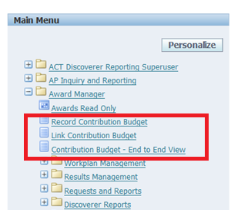

    - Record Contribution Budget Form
Recording of the CB involves the entry of CLs for an award in the “Record Contribution Budget” page based on the requirements contained in the donor agreement. An award must be created, instalments recorded and the award must have its status set to active before a CB can be created against it.
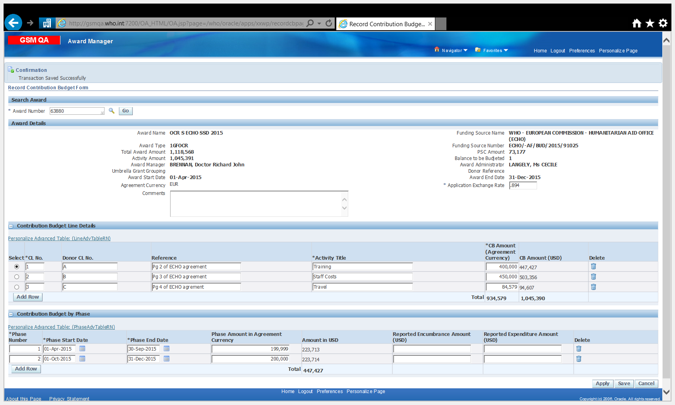
3
2
1
- Search Award and Award Details

The award number is entered in the “search award” field. Once the award is entered, key award information in read-only mode, including whether there are any Umbrella Grant Groupings, will appear in the “award details” zone. An optional comments field is available to enter relevant details concerning the donor agreement.
The application exchange rate automatically defaults to 1 for awards denominated in USD. The application exchange rate automatically defaults to the Descriptive Flexfield (DFF) rate for awards denominated in currencies other than USD and can be updated if required.
The total award amount to be budgeted in the CB is the “activity amount” which is denominated in USD and net of PSC.

- Contribution Budget Line Details

CL details can be entered by selecting “Add Row”. The award amount is split into CLs based on the specifics of the donor agreement and contains the following mandatory (M) and optional (O) fields:
  - CL No.: is an automatically populated field containing a consecutive number for each CL.
  - Donor CL. No.: reference from the donor agreement (O)
  - Reference: from the donor agreement (O)
  - Activity: specifies the type of activity that will take place per the donor agreement (M)
  - CB Amount: includes the amount of the activity for the budget line based on the agreement currency (M). The field CB Amount (USD) will automatically convert the CB amount to USD based on the application exchange rate.
CLs can be deleted by selecting the delete button at the end of the row. CLs cannot be deleted if a task is linked to it and therefore, the task must be delinked in the “Link Contribution Budget” page before proceeding to remove the row.
A message “Total of CB (USD) is greater than the Total Activity Amount” will be displayed if the sum of CB Amount (USD) exceeds the Total Activity Amount (USD). This is a warning message only and the user may continue entering details of the CB if desired.
The details entered in the “Record Contribution Budget” page can be saved at any time by selecting the save button at the bottom of the screen. Similarly, selecting the apply button will also save data; however, the user will be exited from the “Record Contribution Budget” screen.
- Contribution Budget by Phase

The outputs or activities to be funded by the donor agreement may be time-bound and the donor may require WHO to provide interim reports at the end of the defined phases of the implementation period. If this is the case, phases may be defined in the CB in the “Contribution Budget by Phase” section of the “Record Contribution Budget”. Phases are the milestones or deliverables set by the donor. If the milestones or deliverables trigger separate payments in the course of the agreement period, the phases in the CB can be established to tie in with the instalment schedule set up for the award. Setting up phases in the CB is optional.

The phase start and end date must fall within the award start and end dates. Similarly, phase dates cannot overlap across rows nor have time gaps. The dates must be corrected in order to proceed with the CB.

Phases are planned by CL No. Therefore, in order to enter a phase, select the CL No under “Contribution Budget Line Details”, and enter relevant phase information. The following message will appear if the total phase amount exceeds the balance of the CL “Total of Phase Amount (USD) cannot be greater than CB Amount (USD) for CL No. xx”. This must be corrected in order to proceed with the CB. The phase amount in agreement currency, once entered, will automatically calculate the amount in USD based on the application exchange rate.

Phases (Phase number, phase start date and phase end date) when defined for a CL are copied to other CLs automatically.

There are 2 additional fields available in the Contribution Budget by Phase zone: Reported Encumbrance Amount (USD) and Reported Expenditure Amount (USD). Specifically, reported Encumbrance Amount (USD) is available for entering the encumbrance amount actually reported to the donor for the phase while Reported Expenditure Amount (USD) is available for entering expenditure amounts reported to the donor for the phase. Both fields are optional and are manually entered once the phase has lapsed and the amounts have been reported to the donor, for future reference.

    - Link Contribution Budget

Once the CB for an award (A) is recorded, the Award Manager/Award Administrator enters data in the “Link Contribution Budget” page to link the CLs to the tasks (T) in the project (P). Any Task in the task structure hierarchy can be linked to a CL of an award. The ‘Contribution Budget Planning Template’ included in section 1.2 of this SOP (p. 5) can be used to assist in planning the linkages. The CLs can optionally be linked to expenditure types (E) at the task level. Note that the projects for which tasks are being linked must be in approved status and the project must be work plan funded.
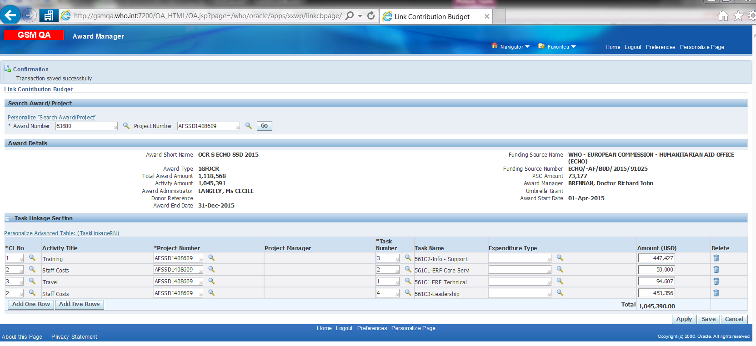
Target Amount (USD)
2
1

- Search Award/Project and Award Details

The award number is entered in the “search award” field. Once the award is entered, key award information in read-only mode will appear in the “award details” zone.
Once the award is selected, the project number for which CLs are to be linked is selected from the drop down menu. This allows the user to link the CLs to the task for the project.

- Task Linkage Section

This zone allows the user to link CLs to tasks and displays task linkages already recorded for the chosen award/project number. It also permits users to delete linkages, add linkage rows or update linkage values for existing rows. Furthermore, on an optional basis, the user may also specify whether the CL No linked to the project and task should also only accumulate expenditure data by expenditure type.
The column Target Amount (USD) is an optional field which is entered manually. It can be used to enter the value of contribution budget for the particular linkage row, for reference purposes.
Tasks of the same hierarchy cannot be linked to CLs if a different level in the hierarchy is already selected. For example, when a top task is linked to a CL, none of its sub tasks or lower tasks can be linked again in the “Link Contribution Budget” page. However, a peer task of the linked task can be linked in the page.
Example:
The task hierarchy for award 63880 is 1 1.1 1.1.1 1.1.1.1 and Tasks 1.2 and 1.3 are peers of 1.1.
- If task 1.1 is linked to a CL, linkages for 1 or 1.1.1 or 1.1.1.1 will not be possible. However, a linkage row for task 1.2 can be added.
- 1.1.1 and 1.1.1.1 will be deemed to have the same linkage as task 1.1
- If task 1 is linked by 1.1, 1.2, and 1.3, the user can still elect to link the CB at the top task level for task 2.

    - Contribution Budget – End to End View
The “Contribution Budget – End to End View” is a read-only page that provides an overall view of the CB and incurred expenditures/encumbrances across projects and tasks linked to the CLs of an award in USD. Data in each region (except the header) of this page can be exported to excel.
The CLs must be entered for the award in the “Record Contribution Budget” page, CLs for the award must be linked to projects, tasks and optionally to expenditure types, and costs must be incurred against the projects and tasks linked to CLs in order to have a comprehensive view of the CB in this page.
Note that the end to end view is refreshed on a daily basis and therefore data entered in the “Record Contribution Budget” page and any new linkages from the “Link Contribution Budget” page will only appear the following day. Further, expenditures linked to the CB (via the task or expenditure type) will only appear a day after the expenditure is incurred.

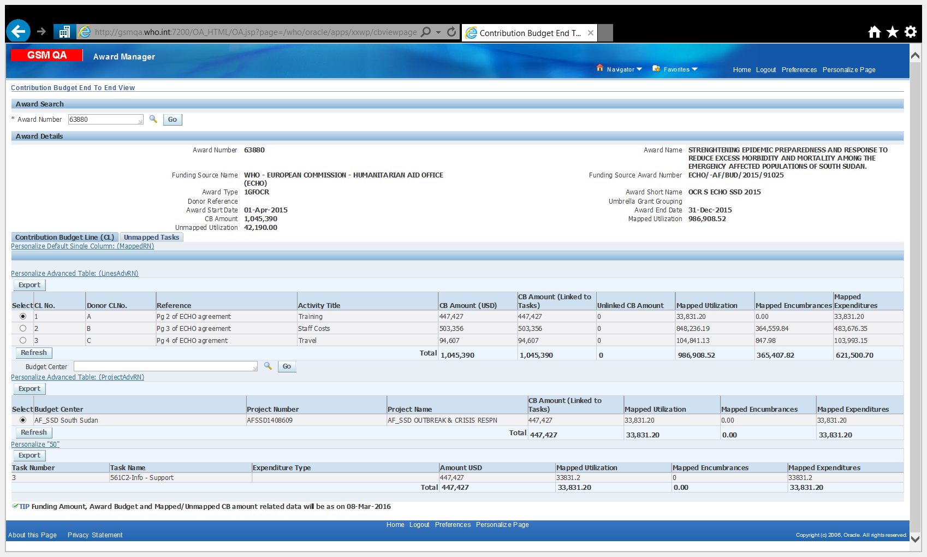
Target Amount (USD)
2
1
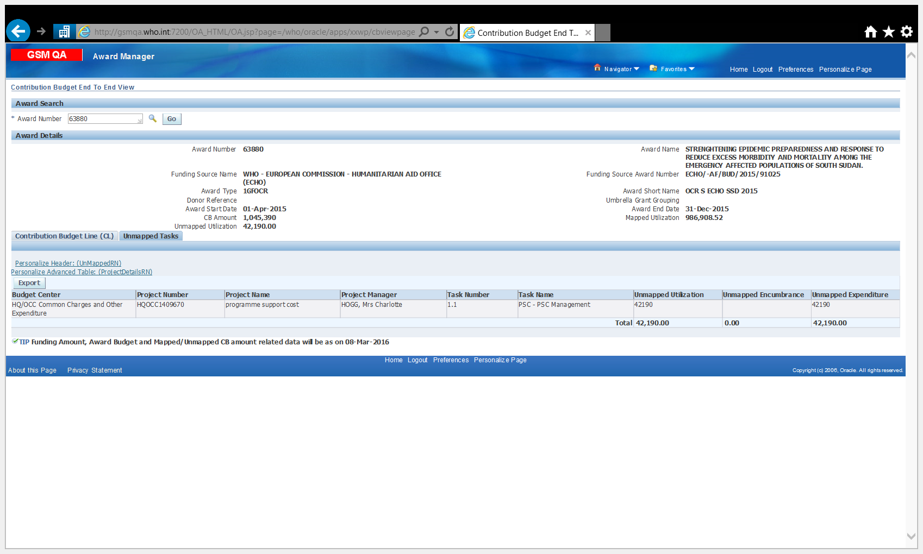
3

- Search Award and Award Details

The award number is entered in the “search award” field. Once the award is entered, key award information in read-only mode will appear in the “award details” zone.
- Contribution Budget Line

In the first section of the “Contribution Budget Line” zone, the CB Amount (USD) for the award as entered in “Record Contribution Budget” page, the Target Amount (USD) (if entered) from the “Link Contribution Budget” page, the unlinked CB Amount, and the mapped utilization (total mapped encumbrance and expenditure amounts for the award separated into mapped encumbrances and mapped expenditures) is displayed.
By selecting the radio button next to the CL No. and hitting refresh, information regarding linked projects appears. By further selecting the radio button next to the relevant project number and hitting refresh, relevant details on mapped tasks are displayed.
The number of project records displayed is approximately 50 per page. Further records can be viewed by clicking the Next button.
All amounts displayed are in USD.
- Unmapped Tasks
Any projects or tasks that are not linked in the “Link Contribution Budget” page will appear in the unmapped tasks tab, along with the unmapped utilization and encumbrance amounts. Further, any tasks which are linked to the CL with a specific expenditure type but where costs are incurred against the task against another expenditure type will appear in the unmapped tasks section.

    - Reports

Four reports are available under “Run Reports/Requests” that display relevant information on the CB. The reports can be run by individuals who have the Award Manager, Award Administrator, Project Specialist or Project Administrator responsibility.

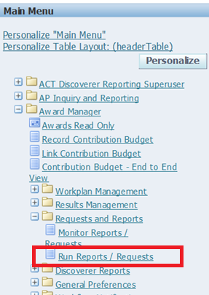 | 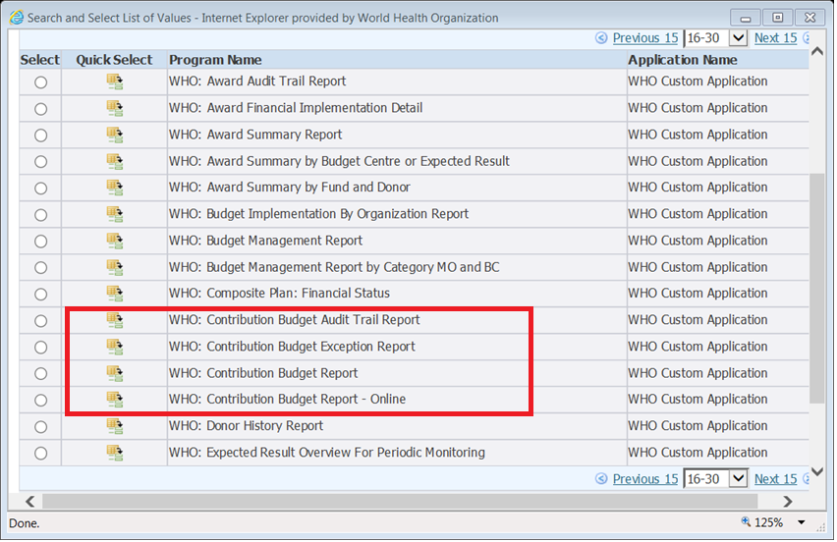

Additionally, information on reported encumbrances and expenditures with reference to CLs is available in the “Encumbrance and Expenditure Analysis – Report” via the Project Administrator responsibility.

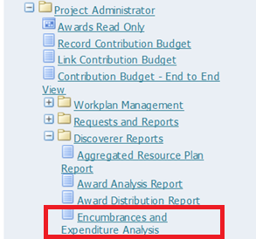

- Contribution Budget Audit Trail Report
The “Contribution Budget Audit Trail Report” is an XML based report that can be run by the user on ad hoc basis to generate audit details regarding changes done to the “Link Contribution Budget” page. Specifically, the report will list the following changes:
- Insertion of new linkage rows
- Deletion of any existing linkage row
- Update of values on any existing linkage row

The report is run by either selecting an Award, Umbrella Grant Grouping, Award Manager, Award Administrator, Budget Centre, Project Number or the Last Update Date From/To. The report is an online report and therefore any changes made to the CB will reflect immediately.

Example “Contribution Budget Audit Trail Report”:

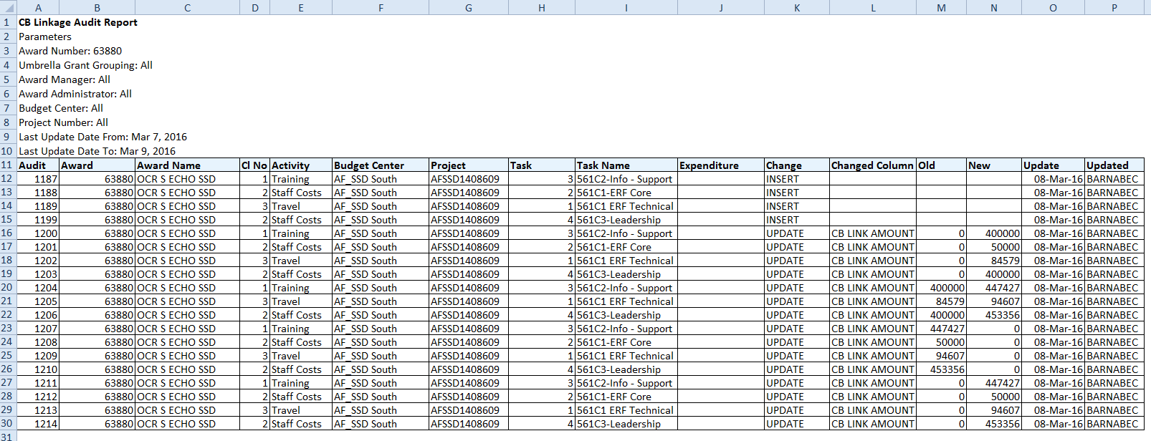

- Contribution Budget Exception Report
The “Contribution Budget Exception Report” is an XML based report that can be run by the user on ad hoc basis (and after expenditures are recorded against PTAEOs) and lists data regarding exception scenarios relating to CB linkages and incurred expenditures/encumbrances.
Specifically, the report will list the following exceptions:
- Project funded but no linkages
- Utilization but no linkages
- Incomplete Contribution Budget

The report is run by selecting an Award, and can be further defined by Umbrella Grant Grouping, Award Manager, Award Administrator and the exception type. The report is refreshed on a daily basis and therefore changes made will only reflect the following day.

Example “Contribution Budget Exception Report”:
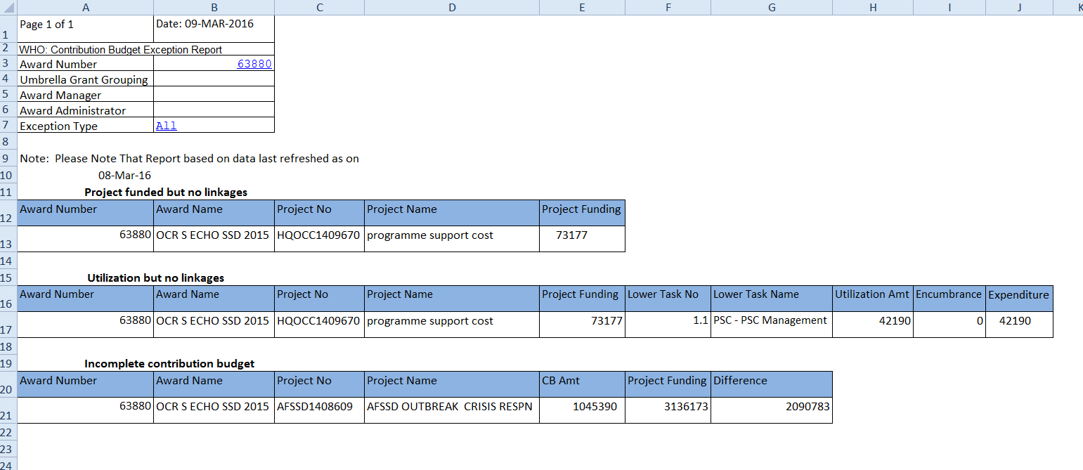
Logic for finding if a PTAEO is not linked to a CL:
- Find whether the CLs for the award are defined. If yes, go to step 2.
- Find whether CLs of the award are linked (at least 1 line). If yes, go to step 3.
- Find whether there are CLs linkages against the particular task in the PTAEO. If yes, go to step 5. If no, go to step 4.
- Find whether there are linkages against any tasks in the higher level hierarchy of this task. e.g. if the task in PTAEO is 1.1.1.1 find whether there are any linkages to tasks 1.1.1, 1.1 or 1. If yes, go to step 5. If no go to step 6.
- If the linkage is against a particular expenditure type in the PTAEO or the expenditure type is null, then the expenditure/encumbrance is a mapped expenditure/encumbrance.
- All other expenditures/encumbrances associated with this PTAEO are considered as unmapped.

- Contribution Budget Report
The “Contribution Budget Report” provides utilization data based on a high-level grouping of the award or by lower level groupings like the CLs or Tasks, and reflects data similar to that as presented in the “Contribution Budget End to End View”. The report is run by selecting either an award, Umbrella Grant Grouping, Award Manager, Award Administrator, GL Date From/To, or the Budget Centre (Project). Further the type of report (Award, Contribution or Task) must be selected:
- Award Level: This is the highest level of grouping where the CB and utilization data will be displayed at only the award level. If the value is “By Award” only the first 12 columns related to Award grouping will be displayed.
- Contribution Budget: The report information would be one level below the award where the split of award level CB and utilization amounts are shown for the CLs. If the value is “By Contribution Budget Line”, the first 23 columns related to Award and Contribution Budget Line groupings will be displayed.
- Tasks: This is the lowest level of data where the split of the CB and utilization data amongst CLs would be further displayed as split among the various tasks linked to the CLs. If the value is “By Task” all columns will be displayed to show the data at all three levels.

The report is an online report and therefore any changes made to the CB will reflect immediately in this extract.

Example “Contribution Budget Report” by Task:

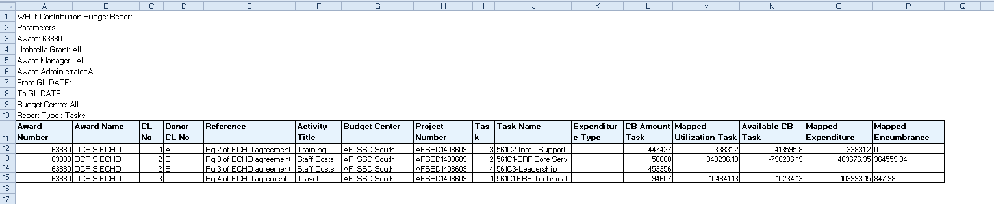

- Contribution Budget Report – Online
The “Contribution Budget Report – Online” is an XML based report that can be run by the user on an ad hoc basis (and after expenditures are recorded against PTAEOs) to generate the CB and utilization data by period (including by pre-defined phases, by year, by quarter, bi-annually, by biennia or across the duration of the award). It is designed to provide information in a format aligned with donor reporting requirements and can display “Reported Amounts” as entered in the “Record Contribution Budget” page if elected. Furthermore, the user can elect to include or not include encumbrances or the Umbrella Grant Grouping.

The report is an online report and therefore any changes made to the CB will reflect immediately in this extract.

Example “Contribution Budget Report- Online”:

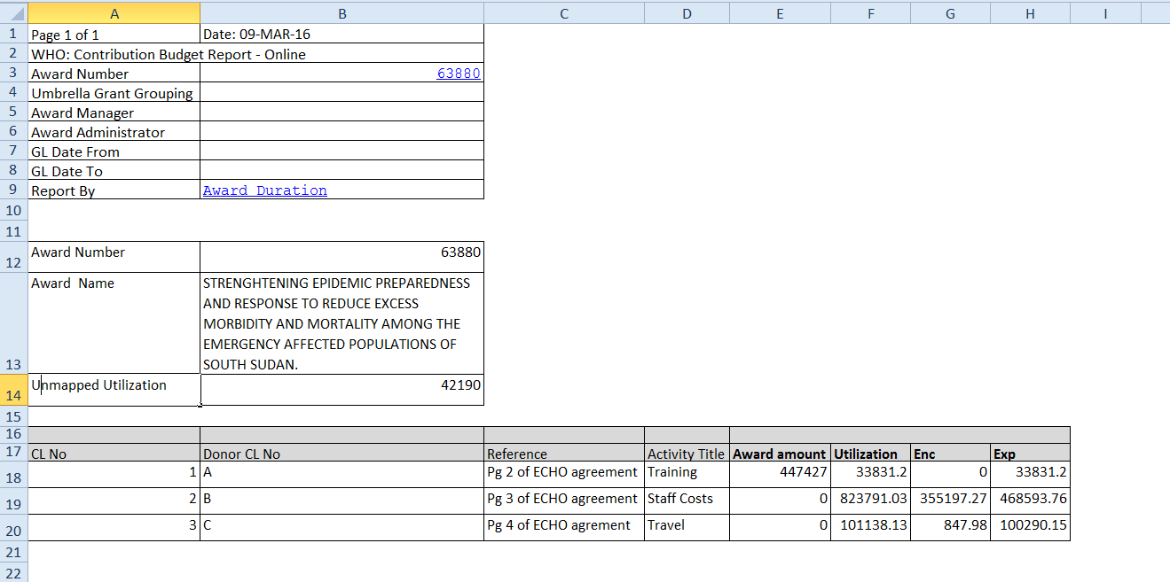
- Encumbrance and Expenditure Analysis – Report
The “Encumbrance and Expenditure Analysis – Report” provides information by award on reported encumbrances and expenditures and includes a column identifying the CL No. linked to the tasks in the “Link Contribution Budget” page.

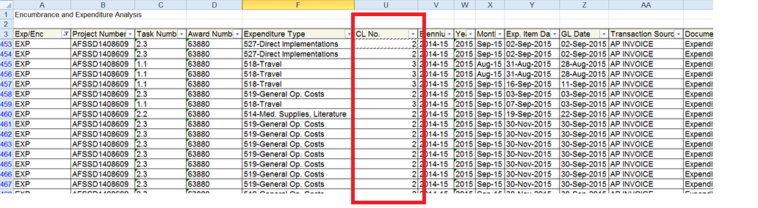

    - Reference Material

- WHO eManual
- IV.3 Award Creation and Management

- Related SOPs
- FIN.SOP.IV.010 Awards End to End
- FIN.SOP.IV.011 Award Creation and Review
- FIN.SOP.IV.025 Certified Donor Financial Statements
- FIN.SOP.IV.029 Entering Award Distributions
- FIN.SOP.IV.030 Entering Workplan Funding
- FIN.SOP.IV.050 Award Distribution Reviews

- PROCESS FLOW

PROCESS STEPS

Step | Control (C) | Type | Process | Role / Responsibility
1 |  | Offline | Completes the Award Activation Request (AAR) upon receipt of a finalized donor agreement between the WHO and the donor. Sends the completed AAR to awards@who.int for award creation. | Award Manager/Administrator
2 |  | GSM | Creates the award in GSM. | Award Creation, GSC
3 |  | GSM | Distributes the award based on the data contained in the AAR, or in the Award Distribution Request (ADR) if not originally specified in the AAR. | Award Creation, GSC
4 |  | GSM | Funds work plans. | Workplan Manager/Assistant
5 |  | GSM | Records the CB in the “Record Contribution Budget” page based on the donor agreement budget. | Award Manager/Administrator
6 |  | GSM | Links the CB to tasks, sub tasks, and lower tasks based on the work plans in the “Link Contribution Budget” phase. | Award Manager/Administrator
7 |  | GSM | Communicates with the work plan manager/ administrator in case new tasks need to be added to existing work plans in order to link a CL to an appropriate task. | Award Manager/Administrator
8 | C | GSM | Reviews details in the “Contribution Budget End to End View” and the data contained in the available reports (Audit Trail, Exception, CB, CB-Online). Identifies unmapped or incorrectly mapped tasks, unmapped or incorrectly mapped CLs and/or expenditures charged to an incorrect PTA based on the CB details. Takes corrective action as necessary. | Award Manager/Administrator
9 | C | GSM | Issues “Financial Management Reports” to the donor based on the “Contribution Budget Report”. | Award Manager/Administrator

- KEY RISKS & COMPENSATING CONTROLS

Risks | Compensating Controls | Process Step
Tasks are unmapped or incorrectly mapped to CLs. CLs are not mapped. | Reviews details in the “Contribution Budget End to End View” and the data contained in the available reports (Audit Trail, Exception, CB, CB-Online). Identifies unmapped or incorrectly mapped tasks, unmapped or incorrectly mapped CLs and/or expenditures charged to an incorrect PTA based on the CB details. Takes corrective action as necessary. | 8
Expenditures are incorrectly charged to a PTA or CL. | Reviews details in the “Contribution Budget End to End View” and the data contained in the available reports (Audit Trail, Exception, CB, CB-Online). Identifies unmapped or incorrectly mapped tasks, unmapped or incorrectly mapped CLs and/or expenditures charged to an incorrect PTA based on the CB details. Takes corrective action as necessary. | 8

